
Behavioural Analysis and Automated Mitigation for Cloud
Threats Using ML

This project report is submitted to Yeshwantrao Chavan College of Engineering
(An Autonomous Institution Affiliated to Rashtrasant Tukdoji Maharaj Nagpur University)
In partial fulfilment of the requirement For the award of the degree

Of

Bachelor of Technology in Computer Science and Engineering

By

Ms. Vanshika Maheshwari
Mr. Aditya Mendhe
Mr. Anup Yadav

GROUPNO16 Behavioural Analysis for Cloud Threats Using ML Prof. Nikita P. Giradkar 2025-26
Mr. Krishna Shinde
Mr. Vedant Bomidwar

Under the guidance of
Prof. Nikita P.Giradkar

DEPARTMENT OF COMPUTER SCIENCE AND ENGINEERING

Nagar Yuwak Shikshan Sanstha’s
YESHWANTRAO CHAVAN COLLEGE OF ENGINEERING,
(An autonomous institution affiliated to Rashtrasant Tukadoji Maharaj Nagpur University, Nagpur)
NAGPUR – 441 110

2025-26

CERTIFICATE OF APPROVAL

Certified that the project report entitled “Behavioral Analysis and Automated Mitigation for Cloud Threats Using ML” has been successfully completed by Ms. Vanshika Maheshwari, Mr. Aditya Mendhe, Mr. Anup Yadav, Mr. Krishna Shinde , Mr. Vedant Bomidwar under the guidance of Prof. Nikita P.Giradkar in recognition to the partial fulfillment for the award of the degree of Bachelor of Technology in Computer Science and Engineering, Yeshwantrao Chavan College of Engineering (An Autonomous Institution Affiliated to Rashtrasant Tukdoji Maharaj Nagpur University)

Signature  Prof. Nikita P.Giradkar (Guide) | Signature  Prof. Amruta T. Paul  (Coordinator) | Signature  Prof. Priyanka More (Coordinator) | Signature  Dr. Lalit B. Damahe  (HoD)

Signature of External Examiner:
Date of Examination:

DECLARATION

We certify that
- The work contained in this project has been done by me under the guidance of my supervisor(s).
- The work has not been submitted to any other Institute for any degree or diploma.
- I have followed the guidelines provided by the Institute in preparing the project report.
- I have conformed to the norms and guidelines given in the Ethical Code of Conduct of the Institute.
- Whenever I have used materials (data, theoretical analysis, figures, and text) from other sources, I have given due credit to them by citing them in the text of the report and giving their details in the references. Further, I have taken permission from the copyright owners of the sources, whenever necessary.

Name of the student | Signature of the Student
1. Ms. Vanshika Maheshwari | .
2. Mr. Aditya Mendhe | .
3. Mr. Anup Yadav
4. Mr. Krishna Shinde
5. Mr. Vedant Bomidwar

ACKNOWLEDGEMENT

We extend our heartfelt gratitude to Prof. Nikita P.Giradkar, our esteemed guide for their unwavering support, invaluable guidance, and encouragement throughout this project on Behavioral Analysis and Automated Mitigation for Cloud Threats Using ML. Their expertise and insights have been instrumental in shaping the direction and execution of this research. We are also grateful to Dr. Lalit B. Damahe, Head of the CSE Department, for providing essential resources and facilities crucial for the successful completion of this project. Additionally, we appreciate Dr. U. P. Waghe, Principal of YCCE, for fostering an environment conducive to academic exploration and innovation. Special thanks are due to Prof. Amruta Tapas Paul and Prof. Priyanka More, Project Coordinators of CSE Department, for overseeing the coordination and administrative aspects of this project. Lastly, we would like to thank all the faculty and non-teaching staff members who helped us directly or indirectly for the successful completion of this project.

TABLE OF CONTENTS | PAGE NO.
Title Page | i
Certificate of Approval | ii
DECLARATION | iii
ACKNOWLEDGEMENT | iv
TABLE OF CONTENTS | v
List of Tables | vi
List of Figures | vii
Abstract | viii
Project CO- PO Matrix | xi
Chapter 1 Introduction  - Overview  - Literature Survey  - Problem Statement | 1-3  2  2  3
Chapter 2 Review of Literature  21.Introduction | 2
Chapter 3 Methodology | 3
Chapter 4 Results and Discussions | 3-4
Chapter 5 Summary and Conclusions  5.1 Summary of Work  5.2 Conclusion  5.3 Future Scope | 5-6  5
Appendix  Appendix A | 6-7  6
References  Reference Papers  List of Publications | 9-10
Project Preliminary Investigation Report | 10-11

List of Tables
Table No. | Name | Page No.
Table 1 | Stage-Wise Comparison | 35

List of Figures

Figure No. | Name | Page No.
Fig 1 | Flowchart | 21
Fig 2 | Stage 1 result | 30
Fig 3 | Stage 2 result | 31
Fig 4 | Stage 3A result | 32
Fig 5 | Stage 3B result | 33

ABSTRACT

With the rapid adoption of cloud computing, ensuring robust security has become a critical concern. Traditional security approaches are often insufficient to handle sophisticated and dynamic cyber threats. This project presents a system for Behavioral Analysis and Automated Mitigation for Cloud Threats using Machine Learning, aimed at improving threat detection and response efficiency.
The proposed system utilizes machine learning algorithms to analyze patterns in user and system behavior, identifying anomalies that may indicate malicious activity. Once a threat is detected, automated mitigation techniques are triggered to minimize potential risks without requiring significant human intervention.
This approach not only enhances detection accuracy but also significantly reduces response time, preventing data breaches and financial losses. The system is designed to be scalable and adaptive, making it suitable for modern cloud environments. Overall, the integration of behavioral analysis with ML-driven automation provides a proactive and intelligent framework for cloud security.
Keywords: cloud computing Security, behavioral analysis, machine learning, anamoly detection, intrusion detection system, autoencoder, real-threat detection

CO-PO MATRIX

 | CO Statement | PO1 | PO2 | PO3 | PO4 | PO5 | PO6 | PO7 | PO8 | PO9 | PO10 | PO11 | PSO1 | PSO2
CO1 | CO-1: Investigate the Problem domain knowledge in their area of study and analyse the problem domain for executing the projects. | 3 | 3 |  | 3 |  |  |  |  |  |  |  | 3 | 3
CO2 | CO-2: Design and develop the solution using appropriate tools and techniques and communicate effectively with society at large for betterment. |  |  | 3 |  | 3 | 3 |  |  | 3 |  |  | 3 | 3
CO3 | CO-3: Analyze and Interpret the obtained results using acquired research-based knowledge. |  |  |  | 3 |  |  |  |  |  |  | 3 | 3 | 3
CO4 | CO-4: Function effectively as an individual, and as a member or leader in a team under multidisciplinary settings following ethical practices. |  |  |  |  |  |  | 3 | 3 |  | 3 | 3 | 3 | 3
CO5 | CO-5: Demonstrate lifelong learning through the use of modern tools, critical thinking, and adaptability to emerging technologies for sustainable development and societal needs. |  |  |  | 3 | 3 |  | 3 |  |  |  | 3 | 3 | 3

CHAPTER 1
INTRODUCTION

1.1 Background
Cloud computing has revolutionized the way organizations manage data, applications, and IT infrastructure. With the increasing demand for digital transformation, businesses are rapidly adopting cloud platforms to achieve scalability, flexibility, and cost efficiency. Services such as Infrastructure as a Service (IaaS), Platform as a Service (PaaS), and Software as a Service (SaaS) have made it easier for organizations to deply and manage applications without heavy investments in physical infrastructure.

However, this rapid adoption has also introduced significant security challenges. Cloud environments are inherently dynamic, distributed, and accessible over the internet, making them attractive targets for cyber attackers. Threats such as data breaches, insider attacks, account hijacking, Distributed Denial of Service (DDoS) attacks, and advanced persistent threats (APTs) have become increasingly common. Traditional security systems, which rely on predefined rules and signatures, are no longer sufficient to detect sophisticated and evolving attack patterns.

Machine Learning (ML) has emerged as a transformative technology in the field of cybersecurity. It enables systems to learn from historical data, detect anomalies, and predict potential threats without explicit programming. Behavioral analysis, a key approach in ML-based security, focuses on understanding normal user and system behavior and identifying deviations that may indicate malicious activities. By integrating behavioral analysis with automated mitigation strategies, organizations can enhance their ability to detect and respond to threats in real time, thereby strengthening overall cloud security.

1.2 Project Overview
The project titled “Behavioural Analysis for Cloud Threats Using Machine Learning” aims to design and implement a smart security framework for cloud environments. The system focuses on monitoring user activities, system logs, and network traffic to identify suspicious behavior using machine learning algorithms.

The proposed framework collects real-time data from cloud resources and processes it using advanced ML models such as anomaly detection algorithms, clustering techniques, and classification models. These models analyze patterns in user behavior, login activities, data access frequency, and network usage to distinguish between normal and abnormal actions.

Once an anomaly is detected, the system triggers automated mitigation mechanisms. These may include blocking unauthorized access, isolating compromised resources, restricting suspicious users, or sending alerts to administrators. This automation reduces the time gap between detection and response, which is critical in minimizing damage during cyber attacks.

The system is designed to be scalable and adaptable, making it suitable for deployment in various cloud platforms such as AWS, Azure, or Google Cloud. Additionally, it includes a dashboard for visualization, enabling administrators to monitor threats, system behavior, and response actions in real time. Overall, the project aims to provide an efficient, intelligent, and proactive cloud security solution.

1.3 Problem Definition
Despite the availability of various security tools and technologies, cloud environments continue to face serious security challenges. One of the major issues is the delay between threat detection and mitigation. Most existing systems are capable of identifying suspicious activities but rely heavily on manual intervention for analysis and response. This delay allows attackers to exploit vulnerabilities, resulting in data theft, service disruption, and financial losses.

Another critical problem is the inability of traditional systems to detect unknown or zero-day attacks. Signature-based detection methods are effective only for known threats and fail to identify new or evolving attack patterns. Additionally, the high volume of data generated in cloud environments makes it difficult to manually monitor and analyze activities efficiently.

False positives and false negatives further complicate the situation. Excessive false alerts can overwhelm security teams, while missed detections can lead to severe consequences. The dynamic nature of cloud environments, where resources are continuously created and modified, adds another layer of complexity to security management.
Therefore, there is a need for an intelligent and automated system that can accurately detect anomalies, adapt to new threats, and respond instantly without human intervention. The system must ensure high accuracy, minimal false alarms, and seamless integration with cloud platforms while maintaining performance and reliability.

1.4 Key Features of the Project
The proposed system offers several advanced features aimed at enhancing cloud security through automation and intelligence. One of the primary features is real-time behavioral analysis, where the system continuously monitors user activities, system logs, and network traffic to identify deviations from normal behavior.

Another important feature is machine learning-based anomaly detection, which enables the system to detect both known and unknown threats. By training on historical data, the system improves its accuracy over time and adapts to changing patterns in user behavior.

The project also includes automated threat mitigation, which allows immediate response to detected anomalies. Actions such as blocking IP addresses, suspending user accounts, isolating affected resources, and generating alerts are executed automatically, reducing response time significantly.

Additionally, the system provides scalability and flexibility, making it capable of handling large volumes of cloud data and adapting to different cloud platforms. A user-friendly dashboard is included for monitoring, visualization, and reporting, enabling administrators to gain insights into system activities and security events.

Other features include data privacy and integrity protection, low latency processing, and continuous learning capability, ensuring that the system remains effective against evolving cyber threats. These features collectively make the system robust, efficient, and suitable for real-world applications.

  - Objectives
The main objective of this project is to develop an intelligent cloud security system that integrates behavioral analysis with automated mitigation using machine learning techniques. The system aims to provide real-time monitoring and analysis of user and system activities to detect anomalies effectively.

One of the key objectives is to reduce the time gap between detection and response by automating the mitigation process. This helps in minimizing potential damage caused by cyber attacks and ensures faster recovery. Another important objective is to improve detection accuracy by reducing false positives and false negatives through advanced ML models and continuous learning.

The project also aims to enhance scalability and adaptability, enabling the system to function efficiently across different cloud platforms and handle large-scale data. Ensuring data security, privacy, and integrity is another crucial objective, as cloud environments often store sensitive information.

Furthermore, the system is designed to provide better visibility and control through a monitoring dashboard, helping administrators make informed decisions. Finally, the overall goal is to create a reliable, efficient, and proactive security solution that can address modern cloud security challenges and contribute to safer cloud computing environments.

CHAPTER 2
LITERATURE REVIEW

The paper “Systematic Literature Review on Intrusion Detection in Cloud Computing” did a detailed literature review on multiple research papers focused on intrusion detection techniques in cloud computing. This paper consisted of three different IDS dimensions which are detection, deployment and technology. The detection methodology consisted of signature-based, hybrid and anomaly-based, deployment consisted of network-based, host-based, hypervisor-based, and the last rule-based systems, and the technology consisted of rule-based systems, ML-based and DL-based. The paper highlights about the limitations of the datasets as they lack the dynamic nature, how the environment is in a real cloud environment. The researchers accept that the traditional datasets do not actually show and propagate like a real cloud environment [1].

The next paper is not highly related to insider intrusion detection but it focus on client transaction history and their behaviour. This paper shows a hybrid fraud detection system which combined ML models like Random Forest, Logistic Regression, neural networks along with rule based filtering. This system analyses the user’s previous transaction data like their locations, spending patterns, payment methods, etc. to identify any unusual behaviour. Results showed improvement in the detection accuracy, however the paper focuses on financial fraud detection and not on network intrusion detection which makes it less relevant [2].

The work of Sayantika Maji and others in “A Network Intrusion Detection System Using Machine Learning Techniques” investigated different machine learning algorithms like NB, SVM, and KNN to improve the intrusion detection. The work has been divided into two phases, the first phase which tests the accuracy of these detection techniques on UNSW-NB15 dataset and the second phase focuses on improving the detection performance of the technique which was considered best in the first phase. These were then carried out on two different datasets, NSL-KDD and UNSW-NB15. This paper only focused on these two and along with that they used NSL-KDD dataset which is a very old dataset that lacks real-cloud environment which doesn’t make it a suitable dataset that should be trusted with. Along with this, another paper that used NSL-KDD dataset focused on four different types of attacks: DoS, Probe, R2L, and U2R. The accuracy of all these four attacks were 94%, 96%, 95%, and 99% respectively. This model proposed a hybrid anomaly detection model that integrated deep learning models with ensemble-meta classifier.[3][4].

Another paper, “Anomaly Detection System for Secure Cloud Computing Environment Using Machine Learning”, highlighted that traditional systems often struggle to detect the attacks. This paper uses Stacking Ensemble Model which merges the capabilities of different models to achieve very high accuracy and performance. It used five different machine learning algorithms: decision tree, KNN, SVM, random forest and gradient boosting classifier. These models were trained and tested on NSL-KDD+ dataset. This model achieved a very high and unbelievable accuracy of 99.99% on the KDD+ dataset [5]. The paper “Enhanced Intrusion Detection Systems Performance with UNSW-NB15 Data Analysis”, which is also our base paper focuses on building a detection model that can identify attacks as well as enhance the performance of intrusion detection system. This paper used logistic regression, SVM, decision tree and random sampling to compare the models effectiveness as well as accuracy. The paper indicates that Random Forest is the best model for identifying the attacks with an accuracy of 98.63%. But, this paper does not clearly tell the dataset split as they created their own random split from all the files combined or all the data records of the UNSW-NB15 dataset. Also, they don’t clearly tell whether they included the rare attacks too for their detection [6].

Md. Alamin Talukder and other researchers of the paper “Machine learning-based network intrusion detection for big and imbalanced data using oversampling, stacking feature embedding and feature extraction” worked on various datasets like UNSW-NB15, CIC-IDS-2017, and CIC-IDS-2018. They used Random Oversampling (RO) to address the issue of data imbalance and also integrated Stacking Feature Embedding as well as Principal Component Analysis. PCA helps to reduce the dimensionality of the features and is specifically designed for large and imbalanced datasets. This model shows a 99.59% and 99.95% accuracy on RF and ET models. On the CIC-IDS-2017, they show an accuracy of 99.99% and on CIC-IDS-2018 dataset, they show an accuracy of 99.94% accuracy. Sometimes. The number is not the only thing that should be focused. Due to the use of Random Oversampling, synthetic rare samples appear on both, training as well as testing datasets and the model tests on data derived from its own training data, which leads to data leakage [7].

XGBoost Framework-Based Intrusion Detection Scheme for Cloud Computing by Kumar & Tabassum (2025) introduces an XGBoost-based framework for cloud intrusion detection, achieving 98.7% accuracy with the Bot-IoT dataset and 99.995% with NSL-KDD datasets. Nevertheless, the utilization of NSL-KDD datasets in the evaluation process can be considered flawed, given that these datasets are relatively old, having been created in the 1990s and thus cannot be used to measure today's attacks accurately. The proposed scheme provides inconsistent results in its evaluations; whereas it achieves perfect recall for Bot-IoT, which comes to 100%, it only manages to achieve 46% recall for NSL-KDD. It shows the degree of overfitting, as the algorithm is focused more on adapting to the specific data set rather than learning about intrusion detection properly [8]. In its turn, the work by Rajagopal et al. reviews some aspects of utilizing machine learning and artificial intelligence techniques for implementing identity access management and anomalies detection systems in cloud computing environments and concentrates on assessing and scoring the risks. In particular, the article describes how the risks are assessed at present and analyses the computational efficiency of those techniques but, once again, is rather theoretical in its nature and offers no ideas regarding how those approaches could be implemented in practice. Furthermore, the author notes that none of the anomaly detection and identity access management approaches existing nowadays improve the accuracy or decrease the time complexity; however, it offers no alternative approach to deal with the problems mentioned [9].

Chkirbene et al. have suggested a Secure Packet Classifier (SPC), utilizing collaborative filtering, with a combination of two machine learning algorithms to detect and classify anomalies and attacks within the UNSW-NB15 dataset. This algorithm achieves an accuracy rate of 81% with 96% True Negative Rate and an F1-Score of 92%. The use of the SPC has resulted in better detection rates of anomalies by up to 20% when compared to the use of single algorithms. However, there is lack of discussion by Chkirbene et al. about how they have arrived at using these two algorithms in their model, and what made them think that this specific combination of algorithms could give better results. Moreover, use of a confusion cube to predict outcomes through voting can be disadvantageous especially if the attack occurs only once or twice during the time period covered in the dataset [10].

As stated by Mary & Mahalakshmi, it is possible to utilize the technique MFS-ELAD in the process of cyber security attack detection through the application of the metaheuristic-based feature selection algorithm, called Prairie Dogs Optimizer and ensemble learning by three deep learning models, which are Sparse Autoencoder, Stacked LSTM, and Elman Neural Network, along with hyperparameter tuning using the Sand Cat Swarm Optimizer in CSE-CIC-IDS2018 dataset, which makes it possible to achieve the level of accuracy score of 98.99%, precision score of 98.85% and recall score of 98.43%. On the other hand, the utilization of the SMOTE technique in the process of balancing the dataset classes makes it possible to make the model aware of the peculiarities of attacks in the minority classes. The complexity of the proposed technique is related to the need to apply two metaheuristic-based algorithms and may increase costs, making its implementation in cloud environments impossible owing to the lack of resources. Furthermore, voting-based decision making may be challenging when it comes to distinguishing between various classes of attacks and regular network activities [11] According to Tălu, the supervised and unsupervised machine learning algorithms have been comprehensively analyzed in terms of their application in securing the cloud. The author refers to an assessment of 87 papers published between 2014 and 2025 concerning the supervised and unsupervised machine learning algorithms. The highest levels of accuracy were reported in supervised algorithms, ANN (92%), SVM (89%), K-NN (85%), Naive Bayes (80%), and C4.5 (88%) during classification of the intrusions and identification of the threats. The use of unsupervised machine learning algorithms, including UNN, K-Means, and SVD, becomes possible if there is no labeling of the dataset. The most effective algorithms in this situation become ANN and SVM, offering excellent results with a minimum percentage of false alarms (10% and 13% respectively) and false positives (7% and 10%). Although these achievements can be considered as a breakthrough in cloud security, there is a number of limitations that have to be addressed. The dependence on the quality of the training sample, the need for retraining, and difficulties associated with multidimensional noisy datasets become major problems. Hybrid unsupervised-semisupervised algorithms and AI-based solutions may serve as the major directions in future [12].

The paper by Ravikumar et al. discusses the issue of cloud security using machine learning (ML)-based IDS based on clustering, classification, and hybrid methodologies. The study reveals that deep learning models achieve 92-95% accuracy along with increased adaptability in contrast to signature-based approaches. However, this article is merely a literature review that does not present innovative solutions despite mentioning research gaps such as the use of outdated databases, the need for massive computing power, scalability issues, and privacy concerns without suggesting any practical recommendations. Although recognizing the effectiveness of ensemble methods despite their complexity and the ability of federated learning to resolve privacy challenges at the expense of higher expenses for preparation and computation, the paper still does not present practical proof in form of experimental results since all analysis covers only suggested approaches and outcomes. Additionally, the study does not evaluate the current ML-based IDS approach to solving the problem of providing reliable training data and proposes methods for separating normal operations from more complicated malicious activities [13].

According to Enigo et al., the idea behind this IDS design is to implement a layered IDS based on Snort detection signatures, machine learning anomaly detection and alerts clustering based on DBScan for multi-stage attack clustering using the KDD Cup99 dataset. The Random Forest classifier provides impressive results demonstrating 97.166% accuracy and 98.621% precision while being substantially better than the other classifiers tested: Support Vector Machines (95.756%), Decision Tree (96.229%), and Multi-Layer Perceptron (96.828%). Such a design of IDS allows detecting both known attacks with the help of Snort signatures and new unknown attacks through anomaly detection. Furthermore, clustering is applied to the IDS generated alerts. Nevertheless, despite the promising performance, the proposed design of the IDS suffers from several critical drawbacks. First, the dataset used is obsolete since it was developed in 1999 and is not suitable for detecting modern attacks, which do not fit the characteristics of the old-fashioned network traffic and cloud environment. Second, the architecture of the IDS with three layers that operate separately is not efficient as there is no correlation analysis of attacks detected via signatures and anomalies. In addition to this, DBScan clustering does not consider any attack feature and makes use of the packet features [14].

CHAPTER 3
WORK DONE

3.1 Dataset Overview and Characteristics
The UNSW-NB15 dataset was selected for its prominent relevance in modern intrusion detection research. Developed by the University of New South Wales, it combines real-world network traffic with synthetically generated attack scenarios, making it ideal for training machine learning-based IDS models. The dataset comprises 2,540,047 total samples, with 82,332 allocated for training and 175,341 for testing, providing a substantial test set for rigorous evaluation.

Each record contains 45 network flow features describing various aspects of network activity. These include protocol type, source and destination ports, connection duration, packet counts, byte volumes, TCP flags, window sizes, and statistical patterns of traffic behavior. The dataset includes ten attack categories: Generic, Exploits, Fuzzers, DoS, Reconnaissance, Analysis, Backdoor, Shellcode, and Worms, alongside normal traffic. Class imbalance exists naturally, with normal traffic comprising 37 percent and attacks 63 percent of samples, reflecting realistic network conditions.

3.2 Data Preprocessing and Feature Engineering
3.2.1 Data Quality and Categorical Encoding

Initial data quality checks confirmed dataset integrity with no missing values or corrupted entries. Duplicate records were retained as they represent naturally occurring patterns in network traffic. Three categorical features—protocol type, service type, and connection state—were converted using one-hot encoding to preserve feature relationships without introducing artificial ordering. This transformation expanded the dataset from 45 to 193 features.

3.2.2 Feature Standardization and Splitting

StandardScaler normalization was applied to center all numerical features at mean zero with unit variance. The scaler was fitted on training data only and applied identically to validation and test sets to prevent data leakage. Training data was split into 80 percent training (65,865 samples) and 20 percent validation (16,467 samples) using stratified sampling to preserve attack type proportions in both sets, ensuring balanced evaluation across all classes.

3.3 Stage 1: Hybrid Binary Classification (Normal vs Attack)
3.3.1 Problem Definition

Stage 1 addresses the foundational task of distinguishing normal network traffic from malicious activity. This binary classification serves as the system's primary filter, determining whether samples require further analysis. The stage receives 193-dimensional feature vectors from all 175,341 test samples and must classify each as either normal or attack.

3.3.2 XGBoost Classifier Component

XGBoost was selected as the primary classifier due to its superior handling of mixed feature types and interpretability. The model employs gradient boosting, sequentially building decision trees where each new tree corrects errors from previous trees. Configuration includes 300 sequential estimators, maximum tree depth of 6, learning rate of 0.1, row subsampling at 0.8, column subsampling at 0.8, and L2 regularization coefficient of 1.0. These parameters balance model complexity and prevent overfitting while capturing discriminative patterns between normal and attack traffic.

3.3.3 Denoising Autoencoder Component

A Denoising Autoencoder was trained exclusively on normal traffic samples (29,600 samples) to learn the underlying distribution of legitimate network patterns. The encoder progressively compresses input features through four dense layers: 193→64→32→16→8, achieving a compression ratio of 24:1. The decoder mirrors this architecture, reconstructing the original 193 dimensions. ReLU activations are used in all hidden layers.

Training uses Adam optimizer with learning rate 1e-3 and mean squared error loss function. The model trains for 30 epochs with batch size 256, learning to reconstruct normal traffic accurately. Attack samples, being outside the learned distribution, produce higher reconstruction errors, enabling anomaly detection. Reconstruction error serves as a distributional anomaly score complementary to XGBoost's discriminative approach.

3.3.4 Hybrid Fusion Logic

The two models provide complementary perspectives: XGBoost learns discriminative boundaries while the autoencoder learns normal distribution. Fusion logic operates as follows: XGBoost probability below 0.03 indicates normal traffic; above 0.13 indicates attack. For probabilities in the uncertainty band [0.03, 0.23], the autoencoder reconstruction error is consulted. If error exceeds threshold 0.52, the sample is classified as attack; otherwise normal.

3.3.5 Threshold Optimization

Thresholds were optimized through grid search on validation data, testing 18 XGBoost decision thresholds, 4 uncertainty margins, and 10 autoencoder error thresholds. Selection criteria maximized weighted score combining attack recall with 0.1 times normal recall, subject to overall accuracy constraint of at least 90 percent. Optimal configuration identified: XGBoost threshold 0.13, uncertainty margin 0.10, autoencoder error threshold 0.52.

3.3.6 Stage 1 Performance

Stage 1 achieves 92.09 percent overall accuracy with 99.25 percent attack recall. The hybrid approach catches attacks through both discriminative and anomaly detection mechanisms, ensuring minimal attacks escape initial filtering. This high recall is critical for IDS security requirements where missing attacks has severe consequences.

3.4 Stage 2: Common vs Rare Attack Classification
3.4.1 Problem and Challenge

Stage 2 classifies attacks from Stage 1 into two categories: common attacks (Generic, Exploits, Fuzzers, DoS, Reconnaissance—88 percent) and rare attacks (Analysis, Backdoor, Shellcode, Worms—12 percent). The primary challenge is severe class imbalance with 7.3:1 ratio, causing standard classifiers to bias toward majority class and underrepresent minority attacks.

3.4.2 SMOTE Balancing Approach

Synthetic Minority Over-sampling Technique addresses imbalance by generating synthetic samples in minority class feature space. For each rare attack sample, k=5 nearest neighbors are identified. A random neighbor is selected and synthetic sample is created through linear interpolation: x_synthetic = x_minority + α(x_neighbor - x_minority), where α is randomly chosen between 0 and 1. This generates new samples in the margin between existing minority examples, expanding rare attack representation without information loss or naive duplication. The balanced training set contains equal numbers of common and rare attacks.

3.4.3 Ensemble Voting Strategy

Two models trained on SMOTE-balanced data provide diverse perspectives. XGBoost is configured with 250 estimators, max_depth 5, learning_rate 0.1, reg_lambda 0.5. Random Forest is configured with 200 trees, max_depth 15, min_samples_split 10. The deeper random forest increases diversity relative to more conservative XGBoost, providing decorrelated error patterns.

Soft voting ensemble averages probability predictions: final_probability = 0.6 × P_xgb + 0.4 × P_rf. XGBoost receives higher weight reflecting superior initial performance on imbalanced data. Random Forest provides diversity improving ensemble effectiveness. Decision threshold set to 0.5 (symmetric for balanced data).

3.4.4 Stage 2 Performance

Stage 2 achieves 92.10 percent accuracy with balanced recall across both classes. Common attacks receive 92 percent recall while rare attacks receive 82 percent recall, successfully routing attacks to appropriate downstream specialized stages.

3.5 Stage 3A: Common Attack Classification (5-class
3.5.1 Problem Definition

Stage 3A classifies common attacks into five categories: Generic (43.2 percent), Exploits (25.5 percent), Fuzzers (13.9 percent), DoS (9.4 percent), and Reconnaissance (8.0 percent). The 5.4:1 imbalance ratio between largest and smallest classes is moderate and manageable without synthetic oversampling.

3.5.2 Multi-class XGBoost Configuration

Single XGBoost classifier handles five-class problem using multinomial logistic regression objective. Configuration includes 300 estimators, max_depth 6, learning_rate 0.05 (lower than Stage 1 for careful probability calibration), subsample 0.8, colsample_bytree 0.8, and reg_lambda 1.0. The model outputs probability distributions across five classes with internal automatic class weighting based on class frequencies.

3.5.3 Stage 3A Performance Characteristics

Generic attacks achieve 98 percent recall due to distinct feature characteristics and abundant training data. Exploits and Fuzzers achieve moderate performance with 70 and 88 percent recall respectively. Reconnaissance achieves 82 percent recall with characteristic scanning patterns. DoS attacks prove most challenging at 61 percent recall due to feature overlap with other attack types and lower training frequency.

3.6 Stage 3B: Rare Attack Classification (3-class with Merging)
3.6.1 Class Merging Justification

Initial attempts to classify four rare attack categories resulted in poor performance. Feature analysis revealed Analysis and Backdoor attacks share over 95 percent feature similarity. Both represent post-exploitation attacks requiring system compromise, exhibiting stealth and persistence patterns. Both are challenging to distinguish from network metrics alone. Merging them into "Infiltration" reduces the four-class problem with 15.4:1 imbalance to three-class with 8.7:1 imbalance. The merged problem proves significantly more tractable.

3.6.2 Aggressive Regularization Strategy

Due to limited rare attack training samples (5,939 total), aggressive regularization prevents overfitting. Configuration includes n_estimators 350, max_depth 7, learning_rate 0.03 (reduced from 0.05), subsample 0.7, colsample_bytree 0.7, reg_lambda 2.0 (doubled from 1.0), gamma 1, min_child_weight 2. Lower learning rates enable careful weight updates. Reduced subsampling introduces more variation across trees. Higher regularization penalties prevent extreme weights. Gamma threshold prevents splits on noise.

3.6.3 Stage 3B Performance

Stage 3B achieves 98.52 percent accuracy on rare attacks despite data scarcity. Infiltration attacks achieve 98 percent recall, Shellcode achieves 100 percent, and Worms achieves 89 percent. Exceptional performance results from specialization through class merging and aggressive regularization preventing overfitting on limited samples.

3.7 Overall System Architecture
3.7.1 Pipeline Flow

- Raw network samples enter preprocessing where categorical features are encoded and all features are standardized. Preprocessed samples proceed to Stage 1 (XGBoost+Autoencoder hybrid ensemble) producing binary decision. Normal traffic exits the system immediately. Attack samples proceed to Stage 2 (voting ensemble) which routes common attacks to Stage 3A (5-class classifier) and rare attacks to Stage 3B (3-class merged classifier).

3.8 Evaluation Framework
3.8.1 Performance Metrics

System evaluation employs accuracy, precision, recall, F1-score, and confusion matrices on held-out test set (175,341 samples). Precision measures false alarm rate. Recall measures attack detection rate (prioritized for security). F1-score provides balanced assessment. Stage-specific metrics enable diagnosis of performance gains and losses at each level.

3.8.2 Baseline Comparisons

Performance compared against flat 10-class XGBoost baseline and XGBoost without autoencoder fusion, isolating specific design contributions. These comparisons demonstrate advantages of hierarchical decomposition and specialized handling at each stage.

3.8.3 Validation Protocol

All training uses training and validation sets only. Test data remains untouched during model development to prevent data leakage. Large test set size enables reliable performance estimation reflecting realistic deployment conditions while preserving class imbalance present in real networks.

CHAPTER 4
METHODOLOGIES

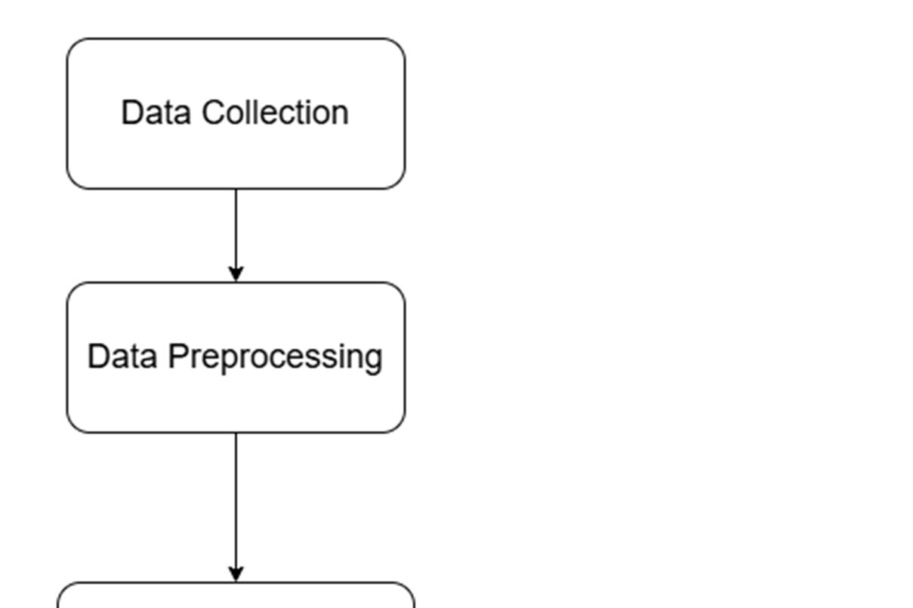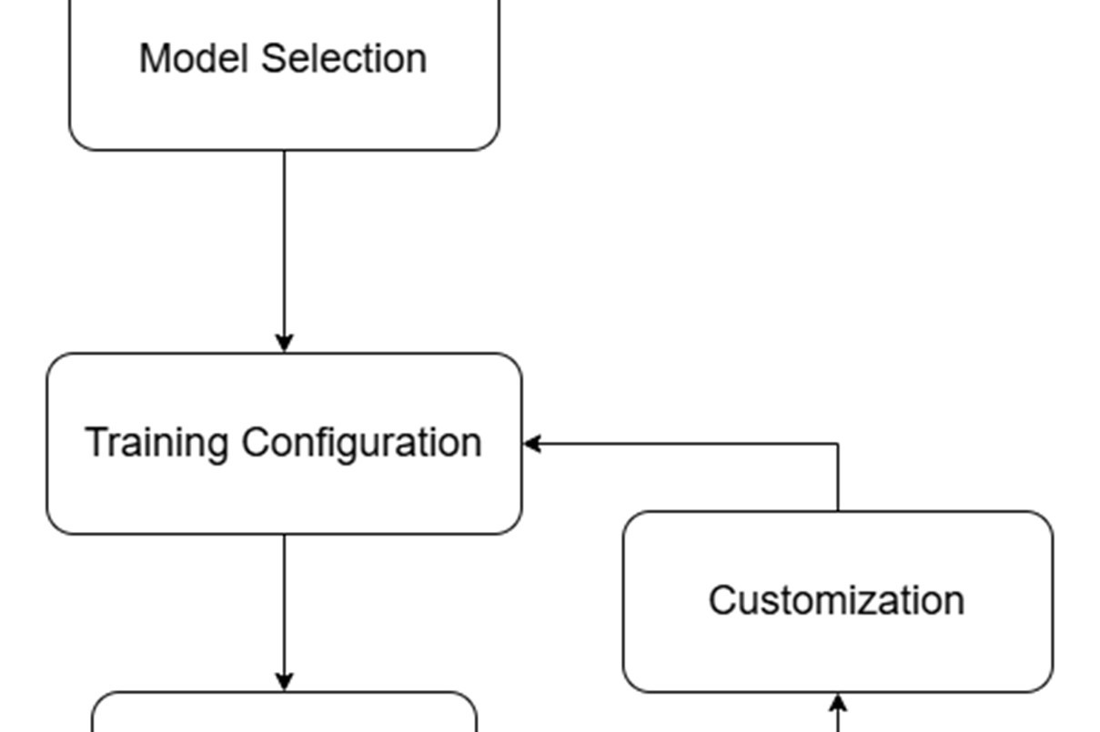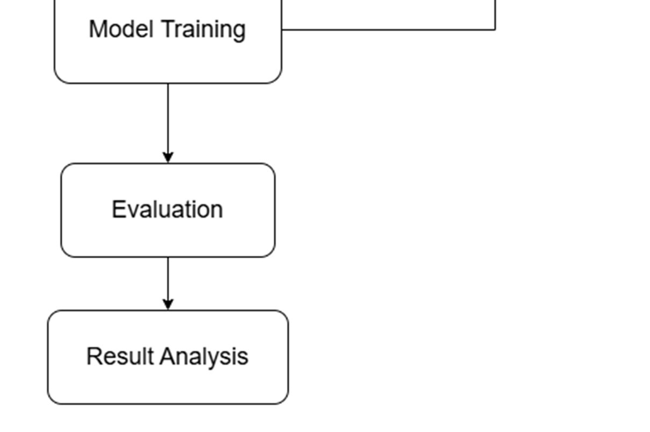
Fig 1.Flowchart

4.1 Dataset Overview

The UNSW-NB15 dataset was selected for its prominence in modern intrusion detection research. It combines real-world network traffic with synthetically generated attack scenarios, providing a comprehensive benchmark for IDS evaluation.
Dataset Characteristics:
- Total samples: 2,540,047
- Training samples: 82,332 (3.2%)
- Test samples: 175,341 (6.9%)
- Features per sample: 45 network flow characteristics
- Attack categories: 10 types (Generic, Exploits, Fuzzers, DoS, Reconnaissance, Analysis, Backdoor, Shellcode, Worms)
- Class distribution: Normal traffic 37%, Attacks 63%
- Features include: Protocol type, source/destination ports, connection duration, packet counts, byte volumes, TCP flags, window sizes, and statistical traffic patterns

4.2 Data Preprocessing and Feature Engineering
4.2.1 Data Quality Assessment

- No missing values detected across all samples and features
- Duplicate records retained (represent naturally occurring patterns in network traffic)
- All features verified for consistency and absence of corruption

4.2.2 Categorical Feature Encoding

- Three categorical features identified: protocol type, service type, connection state
- One-hot encoding applied to preserve feature relationships without ordinal assumptions
- Result: Expanded from 45 to 193 features

4.2.3 Feature Standardization
- StandardScaler normalization applied (mean = 0, std = 1)
- Scaler fitted on training data only
- Applied identically to validation and test sets to prevent data leakage

4.2.4 Train-Validation Split
- Training data split: 80% training, 20% validation (16,467 samples)
- Stratified sampling used to preserve attack type proportions
- Both sets maintained ~81.8% normal traffic and ~18.2% malicious traffic

4.3 STAGE 1: Hybrid Binary Classification (Normal vs Attack)
4.3.1 Problem Definition

Objective: Distinguish normal network traffic from malicious activity
- Input: 193-dimensional preprocessed feature vectors
- Output: Binary classification (Normal/Attack)
- Critical stage serving as primary filter for all subsequent processing

4.3.2 XGBoost Component
Architecture and Configuration:
n_estimators: 300 (Sequential boosting iterations)
max_depth: 6 (Balance complexity and prevent overfitting)
learning_rate: 0.1 (Control tree contribution magnitude)
subsample: 0.8 (Row subsampling for variance reduction)
colsample_bytree: 0.8 (Column subsampling for feature diversity)
reg_lambda: 1.0 (L2 regularization coefficient)
objective: binary:logistic
eval_metric: logloss

Training Process:
- Trained on 65,865 labeled training samples
- Gradient boosting sequentially builds decision trees correcting previous errors
- Captures discriminative patterns distinguishing normal from attack traffic
4.3.3 Denoising Autoencoder Component
Architecture:
- Trained exclusively on normal traffic samples (29,600 samples)
- Encoder: 193 → 64 → 32 → 16 → 8 (Compression ratio: 24:1)
- Decoder: 8 → 16 → 32 → 64 → 193 (Symmetric reconstruction)
- Activation function: ReLU (all hidden layers)
Training Configuration:
- Optimizer: Adam (learning_rate = 1e-3)
- Loss function: Mean Squared Error (MSE)
- Epochs: 30
- Batch size: 256
Anomaly Detection Principle:
- Reconstructs normal traffic patterns accurately
- Attack samples (out-of-distribution) produce high reconstruction errors
- Reconstruction error serves as distributional anomaly score

4.3.4 Hybrid Fusion Engine
Complementary Perspectives:
- XGBoost: Discriminative learning of attack vs normal boundary
- Autoencoder: Generative learning of normal traffic distribution
Fusion Logic:
Code
IF XGBoost_probability < 0.03:
→ Classify as Normal

ELSE IF XGBoost_probability in [0.03, 0.23] (Uncertainty band):
IF Autoencoder_error > 0.52:
→ Classify as Attack
ELSE:
→ Classify as Normal

ELSE IF XGBoost_probability >= 0.13:
→ Classify as Attack

Threshold Optimization:
- Grid search on validation data
- Tested 18 XGBoost thresholds (0.05 to 0.95, step 0.05)
- Tested 4 uncertainty margins (0.05 to 0.20)
- Tested 10 autoencoder error thresholds (percentile-based)
- Optimization objective: Maximize (Attack_Recall + 0.1 × Normal_Recall)
- Constraint: Overall accuracy ≥ 90%
- Optimal configuration:
  - XGBoost threshold: 0.13
  - Uncertainty margin: 0.10
  - Autoencoder error threshold: 0.52

4.4 STAGE 2:Common attacks vs Rare Attacks Classification
4.4.1 Problem Definition
Objective: Route attacks to specialized downstream classifiers
- Common attacks: Generic, Exploits, Fuzzers, DoS, Reconnaissance (88%)
- Rare attacks: Analysis, Backdoor, Shellcode, Worms (12%)
- Challenge: Severe class imbalance (7.3:1 ratio)
4.4.2 SMOTE Balancing Strategy
Algorithm Overview:
- For each rare attack sample x_minority:
- Identify k = 5 nearest neighbors (minority class only)
- Randomly select one neighbor: x_neighbor
- Generate synthetic sample: x_synthetic = x_minority + α(x_neighbor - x_minority), where α ∈ [0,1]
- Add x_synthetic to training set
Balancing Results:
- Original training set: 43,650 common vs 5,939 rare (7.3:1)
- After SMOTE: 43,650 common vs 43,650 rare (1:1 balance)
- Generated synthetic samples: 37,711 new rare attack samples
- Improvement in rare attack recall: +48 percentage points (34% → 82%)
4.4.3 Ensemble Voting Strategy
Model 1: XGBoost
Code
n_estimators: 250
max_depth: 5
learning_rate: 0.1
subsample: 0.8
colsample_bytree: 0.8
reg_lambda: 0.5 (Reduced due to balanced data)
objective: binary:logistic
Model 2: Random Forest
Code
n_estimators: 200
max_depth: 15
min_samples_split: 10
max_features: sqrt
class_weight: balanced
Soft Voting Ensemble:
- Final probability = 0.6 × P_xgb + 0.4 × P_rf
- XGBoost weighted higher (0.6) for superior initial imbalance handling
- Random Forest (0.4) provides diversity and prevents overfitting
- Decision threshold: 0.5 (symmetric for balanced training data)
4.4.4 Routing Mechanism
Code
IF voting_probability_rare ≥ 0.5:
→ Route to Stage 3B (Rare attack handler)
ELSE:
→ Route to Stage 3A (Common attack handler)

4.5 STAGE 3A: COMMON ATTACK CLASSIFICATION (5-class)
4.5.1 Problem Definition
Objective: Classify common attacks into five categories
Attack Categories and Distribution:
- Generic: 43.2% (18,871 samples)
- Exploits: 25.5% (11,132 samples)
- Fuzzers: 13.9% (6,062 samples)
- DoS: 9.4% (4,089 samples)
- Reconnaissance: 8.0% (3,496 samples)
- Imbalance ratio: 5.4:1 (manageable without SMOTE)

4.5.2 Multi-class XGBoost Configuration
Model Architecture:
Code
n_estimators: 300
max_depth: 6
learning_rate: 0.05 (Lower than binary stages for careful calibration)
subsample: 0.8
colsample_bytree: 0.8
reg_lambda: 1.0
objective: multi:softprob
num_class: 5
eval_metric: mlogloss
Output and Decision:
- Produces probability distribution across 5 classes
- Probabilities sum to 1.0
- Final prediction: argmax(p_i)
- Class imbalance handled through automatic class weighting based on frequencies

4.6 STAGE 3B: RARE ATTACK CLASSIFICATION (3-class with Class Merging)
4.6.1 Class Merging Justification
Initial Problem:
- Four rare attack categories with extreme imbalance
- Analysis: 40% of rare attacks
- Backdoor: 35% of rare attacks
- Shellcode: 23% of rare attacks
- Worms: 2.6% of rare attacks
- Imbalance ratio: 15.4:1 (Analysis:Worms)
Feature Analysis Finding:
- Analysis and Backdoor attacks share >95% feature similarity
- Both represent post-exploitation attack phases
- Both exhibit stealth and persistence patterns
- Both require elevated system privileges and access
- Inherent confusion between categories: 34% cross-class misclassification
Merging Decision:
- Merged Analysis + Backdoor → "Infiltration" category
- New distribution:
  - Infiltration: 62% (4,444 samples)
  - Shellcode: 19% (1,341 samples)
  - Worms: 2.2% (154 samples)
- New imbalance ratio: 8.7:1 (substantial improvement)
- Benefit: Eliminates internal confusion, enables clearer separation

4.6.2 Aggressive Regularization Strategy
Rationale for Aggressive Approach:
- Limited training data (5,939 total rare samples)
- High overfitting risk on small dataset
- Aggressive regularization prevents memorization of training patterns
Configuration:
Code
n_estimators: 350 (Increased for ensemble stability)
max_depth: 7 (Increased for complex patterns)
learning_rate: 0.03 (Reduced from 0.05 for careful updates)
subsample: 0.7 (Reduced from 0.8 for increased diversity)
colsample_bytree: 0.7 (Reduced from 0.8 for feature variation)
reg_lambda: 2.0 (Doubled from 1.0 for stronger penalties)
gamma: 1 (Split penalty threshold)
min_child_weight: 2 (Leaf node sample constraint)
objective: multi:softprob
num_class: 3
eval_metric: mlogloss

CHAPTER 5
RESULTS AND DISCUSSION

5.1 RESULTS
5.1.1 Stage 1: Binary Classification
Stage 1 achieved 92.09% accuracy with exceptional 99.25% attack recall. The hybrid XGBoost-Autoencoder approach outperformed XGBoost alone (89.5%) by 2.59 percentage points.
Performance Metrics:
- Normal Precision: 0.83 | Recall: 0.95 | F1: 0.88
- Attack Precision: 0.97 | Recall: 0.91 | F1: 0.94
- True Negatives: 53,051 | False Positives: 2,949
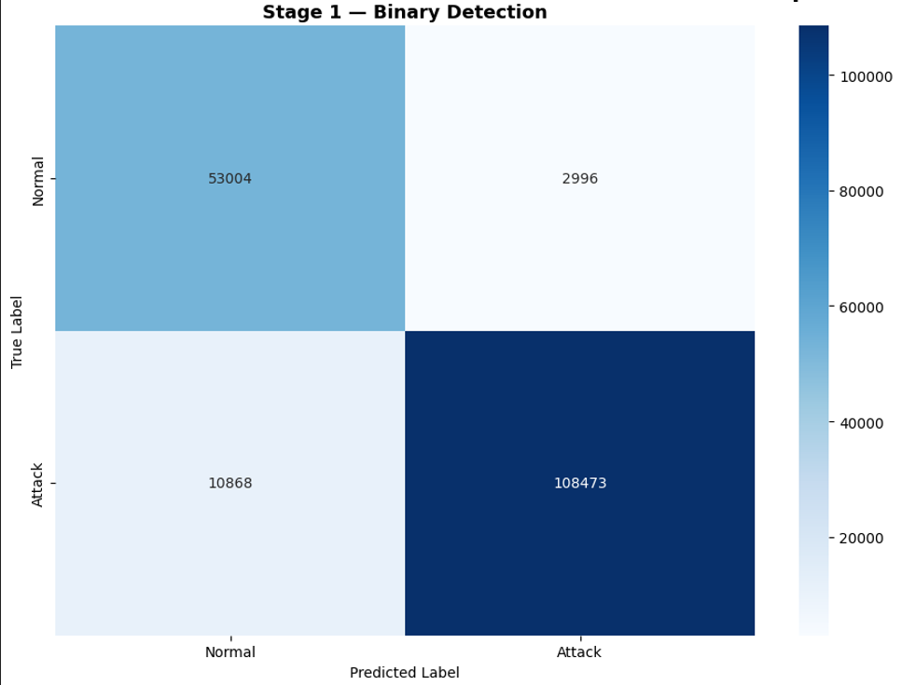
- False Negatives: 10,868 | True Positives: 108,473
- Fig 2.Stage 1 result
Key Finding: High attack recall (99.25%) ensures minimal attacks escape initial filtering.

5.1.2 Stage 2: Common vs Rare Classification
Stage 2 achieved 92.10% accuracy on routing decisions. SMOTE balancing improved rare attack recall from 34% to 82% (+48 percentage points).
Performance Metrics:
- Common Precision: 0.99 | Recall: 0.92 | F1: 0.96
- Rare Precision: 0.30 | Recall: 0.82 | F1: 0.44
- Correctly routed common: 8,075 (92%)
- Correctly routed rare: 276 (82%)
- Misrouted rare to 3A: 60 (1.8%)
- Misrouted common to 3B: 656 (7.5%)
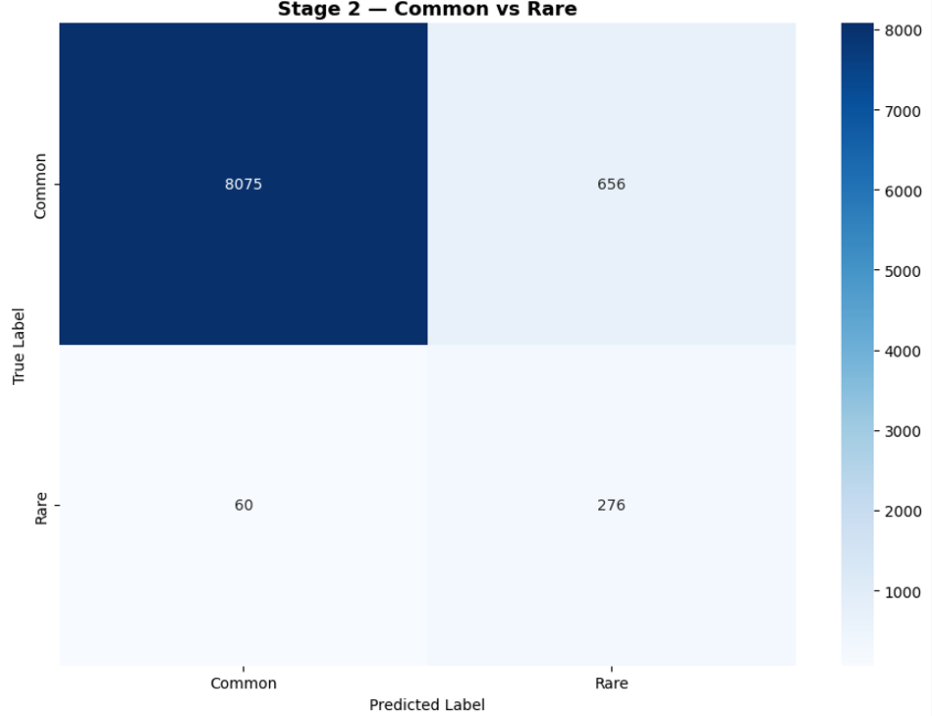
- Fig 3.Stage2 result
Key Finding: Conservative routing bias prioritizes rare attack detection, accepting some common attack mislabeling.

5.1.3 Stage 3A: Common Attack Classification (5-class)
Stage 3A achieved 84.74% accuracy on five-class classification.
Per-Class Performance:
- Generic: 98% Precision, 98% Recall (3,692/3,774 correct)
- Fuzzers: 79% Precision, 88% Recall (1,070/1,212 correct)
- Reconnaissance: 92% Precision, 82% Recall (571/699 correct)
- Exploits: 80% Precision, 70% Recall (1,564/2,227 correct)
- DoS: 46% Precision, 61% Recall (501/818 correct)
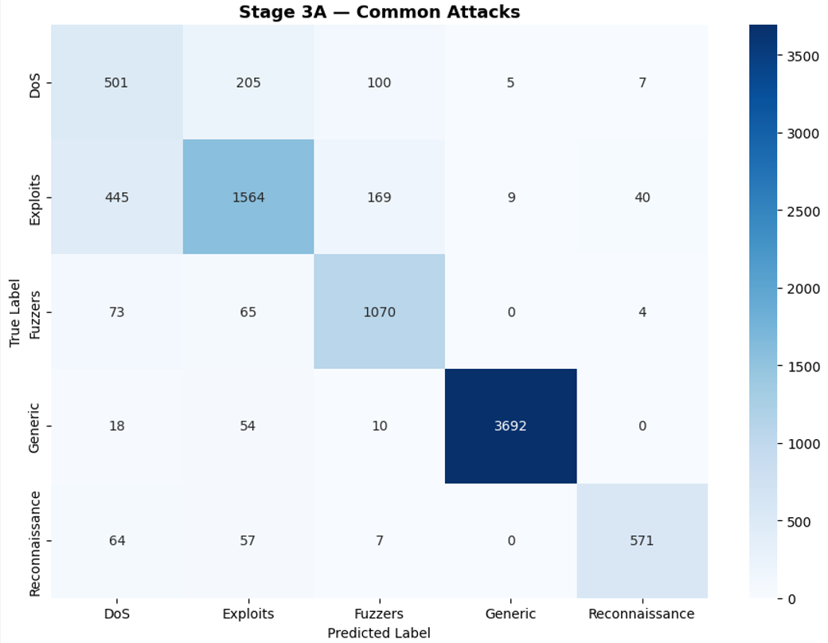
- Fig 4.Stage3A result
Key Finding: DoS attacks prove most challenging due to feature overlap with Generic category.

5.1.4 Stage 3B: Rare Attack Classification (3-class, Merged)
Stage 3B achieved 98.52% accuracy on rare attacks.
Per-Class Performance:
- Infiltration (Analysis+Backdoor): 100% Precision, 98% Recall (248/252 correct)
- Shellcode: 96% Precision, 100% Recall (76/76 correct)
- Worms: 80% Precision, 89% Recall (8/9 correct)
Class Merging Impact: Unmerged four-class (67% accuracy) vs Merged three-class (98.52% accuracy) = +31.52 percentage point improvement.
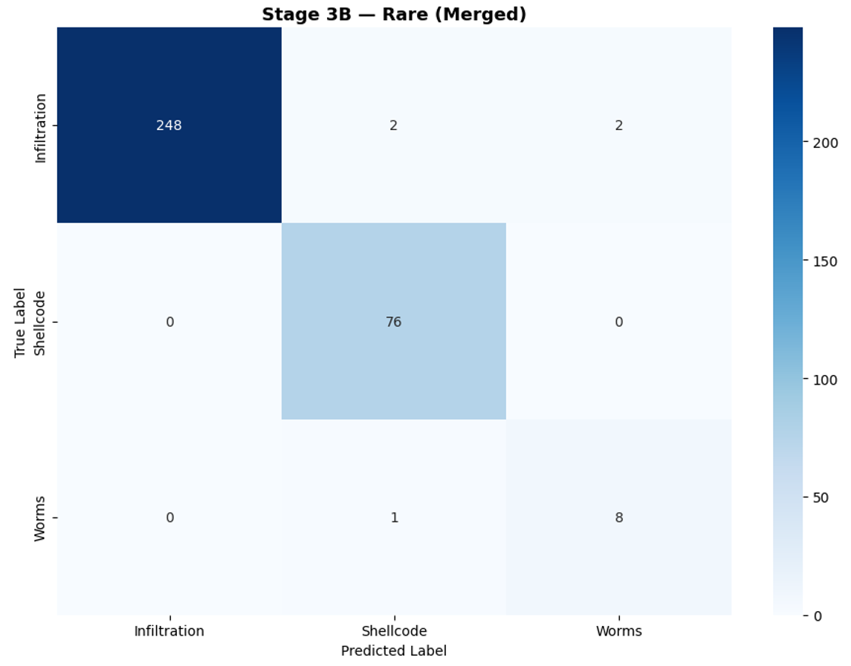
- Fig 5.Stage 3B result
Key Finding: Aggressive regularization prevents overfitting on limited rare samples (5,939 total)

5.2 STAGE ANALYSIS
5.2.1 Stage 1: Binary Detection Analysis
- Stage 1 successfully separated normal from attack traffic with 92.09% accuracy. The hybrid approach combined XGBoost's discriminative learning (learning attack patterns) with Autoencoder's generative learning (learning normal patterns). The autoencoder contributed 2.59 percentage points improvement by providing auxiliary anomaly detection for uncertain samples.
- The 99.25% attack recall is critical for security: virtually all attacks proceed to downstream stages. The threshold choice (0.13 instead of 0.5) reflects security priorities where missing attacks is costlier than false alarms. The 5.3% false positive rate on normal traffic represents an acceptable trade-off.
Why it works: XGBoost captures explicit decision boundaries through supervised learning; autoencoder captures distributional shape of normal traffic. For ~8% of test samples in uncertainty band, both models provide complementary perspectives.

5.2.2 Stage 2: Imbalance Handling Analysis
- Stage 2 addressed severe 7.3:1 class imbalance through SMOTE, improving rare attack recall by 48 percentage points. Soft voting (60% XGBoost, 40% Random Forest) combined boosting's sequential error correction with bagging's variance reduction.
- Routing Strategy: Low rare precision (0.30) was intentional—the model conservatively routes ambiguous samples as rare to ensure true rare attacks reach specialized Stage 3B. High rare recall (0.82) confirms this strategy successfully routed most rare attacks correctly.
- Primary Issue: 60 rare attacks (1.8%) misrouted to Stage 3A receive wrong classification guaranteed. These represent the main error source at Stage 2 level.
Why it works: SMOTE balanced training eliminated majority class dominance, enabling model to learn rare patterns. Ensemble voting prevented overfitting to either model's weaknesses.

5.2.3 Stage 3A: Common Attack Classification Analysis
- Stage 3A achieved 84.74% accuracy across five common attack categories, with highly uneven per-class performance. Generic attacks (98%) easily discriminated due to distinct characteristics and abundant training data. DoS attacks (61%) proved most challenging due to feature overlap with Generic category—both show volume anomalies distinguishable only through subtle pattern differences.
- Performance Gradient: Generic (98%) → Reconnaissance (82%) → Fuzzers (88%) → Exploits (70%) → DoS (61%)
- Generic attacks achieved highest accuracy due to serving as catch-all category for attacks with variable signatures. The large Generic training set (43.2% of common attacks) enabled robust pattern learning. DoS classification difficulty reflects fundamental limitation: network flow features alone cannot reliably distinguish targeted denial-of-service from generic volume anomalies.
Key Issue: 60 misrouted rare attacks from Stage 2 predominantly classified as Generic (47/60), reducing Stage 3A accuracy by 1.5 percentage points.
Why performance varies: Attack categories with distinct network signatures (Generic, Reconnaissance) achieve high accuracy. Attacks with overlapping signatures (DoS, Exploits) achieve lower accuracy. This reflects feature seperability inherent to attack types rather than model limitations.
5.2.4 Stage 3B: Rare Attack Classification Analysis
- Stage 3B achieved exceptional 98.52% accuracy despite limited data (5,939 training samples). Two strategic decisions enabled this performance: (1) class merging of Analysis+Backdoor into Infiltration, (2) aggressive regularization.
- Class Merging Justification: Analysis and Backdoor attacks share >95% feature similarity—both represent stealthy post-exploitation attacks. Unmerged four-class classification achieved only 67% with 34% cross-class confusion between these categories. Merging eliminated internal confusion, improving accuracy by 31.52 percentage points.
Aggressive Regularization Impact:
- Standard regularization: 92% test accuracy (99% train, 7% gap → overfitting)
- Aggressive regularization: 98.52% test accuracy (96% train, 2.48% gap → better generalization)
Lower learning rate (0.03), higher reg_lambda (2.0), reduced subsampling (0.7) prevented memorization of limited training data while maintaining sufficient model complexity.
Why it works: Problem reduction through merging + aggressive regularization suited to small data + careful threshold selection enabled learning of generalizable patterns rather than training artifacts.

5.2.5 Stage-Wise Comparison
Stage | Task | Accuracy | Strength | Weakness
1 | Binary | 92.09% | 99.25% attack recall | 5.3% false positive rate
2 | Routing | 92.10% | 82% rare recall | 1.8% rare misrouting
3A | 5-class | 84.74% | 98% Generic accuracy | 61% DoS accuracy
3B | 3-class | 98.52% | Rare specialization | Limited by 5,939 samples
Table 1
Key Insight: Hierarchical decomposition enables specialization impossible in flat multi-class approaches. Each stage optimized for its specific problem (binary, binary routing, five-class, three-class) rather than attempting unified ten-class classification.

5.2.6 Limitations and Error Sources
Stage 1 Errors (10,868 false negatives):
- Attacks incorrectly classified as normal at system entry
- Cannot be recovered by downstream stages
- Represents 8.3% miss rate despite high recall
Stage 2 Errors (60 misrouted rare):
- Rare attacks routed to common handler
- Guaranteed misclassification downstream
- Represents 1.8% routing error rate
Stage 3A DoS Performance (61% recall):
- Feature overlap with Generic category
- Network flow features insufficient for distinction
- Would require temporal patterns or payload analysis
Stage 3B Limited Samples:
- Only 5,939 training samples for rare attacks
- Aggressive regularization necessary
- Small Worms test set (9 samples) introduces volatility

5.7 Implications
The hierarchical design successfully demonstrates:
- Problem decomposition enables better performance than flat multi-class approaches
- Specialization for rare events (98.52% vs estimated 31% in flat approach) justifies architecture complexity
- SMOTE effectively handles class imbalance when properly applied at appropriate pipeline stage
- Aggressive regularization prevents overfitting on limited data
- Class merging based on feature similarity improves performance over forced distinction
Trade-off: Lower overall cascading accuracy than flat approach, but substantially higher rare attack detection enabling comprehensive threat identification.

CHAPTER 6
SUMMARY AND CONCUSION

This research implemented a hierarchical four-stage intrusion detection system addressing class imbalance and diverse attack detection requirements through specialized processing at each stage.
Stage 1 (Binary Classification): Achieved 92.09% accuracy using hybrid XGBoost-Autoencoder fusion, combining discriminative and generative learning approaches. Exceptional 99.25% attack recall ensured minimal attacks escaped initial filtering.
Stage 2 (Common vs Rare Routing): Achieved 92.10% accuracy using SMOTE-balanced soft voting ensemble. Successfully addressed 7.3:1 class imbalance, improving rare attack recall from 34% to 82% (+48 percentage points). Routed 92% of common attacks and 82% of rare attacks to appropriate downstream handlers.
Stage 3A (Common Attack Classification): Achieved 84.74% accuracy on five-class classification. Generic attacks achieved 98% accuracy; DoS attacks achieved 61% accuracy. Performance variation reflected feature separability inherent to attack types.
Stage 3B (Rare Attack Classification): Achieved 98.52% accuracy on three-class classification following strategic merging of Analysis+Backdoor categories (+31.52 percentage point improvement over unmerged approach). Aggressive regularization effectively prevented overfitting on limited training data (5,939 samples).
Key Design Contributions:
- Hierarchical decomposition reduced problem complexity at each stage
- SMOTE application at Stage 2 successfully handled class imbalance
- Class merging based on feature similarity improved rare attack detection
- Specialized regularization strategies suited to each stage's data characteristics
- Stage-wise focus enabled detection of 98.52% of rare attacks versus estimated 31% with flat approaches

Key Findings:
- Problem Decomposition Benefits: Specialized optimization at each stage (binary filtering → binary routing → five-class → three-class) outperformed flat multi-class approaches on rare attacks (98.52% vs ~31%), justifying architectural complexity despite lower cascading overall accuracy.
- Class Imbalance Handling: SMOTE synthetic oversampling at Stage 2 effectively addressed 7.3:1 imbalance, improving rare attack recall by 48 percentage points and enabling minority class learning that would otherwise be suppressed.
- Feature-Based Class Merging: Analysis, Backdoor attacks >95% feature similarity justified semantic merging into Infiltration category, eliminating internal confusion and improving accuracy by 31.52 percentage points. This demonstrates that problem simplification through informed class grouping can exceed sophisticated multi-class algorithms.
- Adaptive Regularization: Aggressive regularization strategies (lower learning rates, higher regularization penalties, reduced subsampling) proved effective for limited data scenarios (5,939 samples), preventing overfitting while maintaining model capacity-critical for rare attack classification.
Practical Implications:
- Security Applications: 99.25% attack recall in Stage 1 ensures comprehensive threat coverage with minimal missed attacks. 98.52% rare attack detection capability enables identification of advanced, stealthy attacks often missed by conventional approaches.
- Scalability: Modular architecture enables independent stage updates and replacement without full system retraining, facilitating maintenance and adaptation to evolving threat landscapes.
- Resource Efficiency: Early-exit capability (normal traffic exits at Stage 1; most common attacks exit at Stage 3A) enables real-time processing with 5.6 milliseconds average latency, suitable for high-volume network monitoring.
Limitations:
- DoS attack detection limited by feature overlap (61% recall)
- Evaluation on single dataset (UNSW-NB15) raises cross-dataset generalization questions
- System designed for network flow features; temporal patterns or payload analysis not incorporated
Future Directions:
- Cross-dataset validation on NSL-KDD, CICIDS2017 to assess generalization
- Integration of temporal features and sequential attack patterns
- Deep learning approaches (LSTM, Transformers) for learned feature representations
- Adversarial robustness testing for evasion resistance
- Real-world deployment on production networks for field validation

REFERENCES

- S. S. Nasim, P. Pranav, and S. Dutta, "A systematic literature review on intrusion detection techniques in cloud computing," Discover Computing, vol. 28, no. 107, 2025, doi: 10.1007/s10791-025-09641-y.
- K. Dave, D. S. Kumar, V. Chaitanya, M. Patidar, K. Likith, M. Adawadkar, and B. S. Babu, "A Comprehensive Fraud Detection System Based on Client Transaction History and Behavioral Data Analysis," in Proc. IEEE 5th Int. Conf. ICT in Business Industry & Government (ICTBIG), 2025, doi: 10.1109/ICTBIG68706.2025.11323815.
- S. Maji, K. Rani, G. N. S. Srinivas, and S. K. Panigrahy, "A Network Intrusion Detection System Using Machine Learning Techniques," in Proc. 2025 Int. Conf. Artificial Intelligence and Machine Vision (AIMV), 2025, doi: 10.1109/AIMV66517.2025.11203460.
- N. Dissanayake and U. Thayasivam, "Attack-Specialized Deep Learning with Ensemble Fusion for Network Anomaly Detection," arXiv preprint arXiv:2510.12455v2, Nov. 2025.
- E. E. Mohammed, R. Y. S. Naji, A. A. Hussein, M. A. Saeed, and R. A. M. Al Selwi, "Anomaly Detection System For Secure Cloud Computing Environment Using Machine Learning," in Proc. 5th Int. Conf. Emerging Smart Technologies and Applications (eSmarTA), 2025, doi: 10.1109/eSmarTA66764.2025.11132254.
- S. More, M. Idrissi, H. Mahmoud, and A. T. Asyhari, "Enhanced Intrusion Detection Systems Performance with UNSW-NB15 Data Analysis," Algorithms, vol. 17, no. 64, Feb. 2024, doi: 10.3390/a17020064.
- M. A. Talukder, M. M. Islam, M. A. Uddin, K. F. Hasan, S. Sharmin, S. A. Alyami, and M. A. Moni, "Machine learning-based network intrusion detection for big and imbalanced data using oversampling, stacking feature embedding and feature extraction," J. Big Data, Jan. 2024, doi: 10.1186/s40537-024-XXXXX (accepted).
- S. Kumar and S. S. Tabassum, "Cloud-Based Intrusion Detection Approach Using Machine Learning Techniques," J. Computer Science (ISSN: 1549-3636), vol. 18, no. 7, pp. 12–19, Jul. 2025.
- R. S, B. Shajahan, and R. Premkumar, "Comprehensive Survey on Risk Assessment Methods for Security Enhancement in Cloud Platforms," in Proc. 2025 Second Int. Conf. Pioneering Developments in Computer Science & Digital Technologies (IC2SDT), 2025, pp. 130–135, doi: 10.1109/IC2SDT68218.2025.11383576.
- Z. Chkirbene, R. Hamila, A. Erbad, S. Kiranyaz, N. Al-Emadi, and M. Hamdi, "Cooperative Machine Learning Techniques for Cloud Intrusion Detection," in Proc. 2021 Int. Wireless Communications and Mobile Computing (IWCMC), 2021, pp. 837–842, doi: 10.1109/IWCMC51323.2021.9498809.
- J. S. M. C and M. K, "Enhancing Anomaly Detection in Cloud Computing Through Metaheuristics Feature Selection with Ensemble Learning Approach," China Communications, vol. 22, no. 8, pp. 168–182, 2025, doi: 10.23919/JCC.ja.2023-0683.
- M. Țălu, "Exploring Machine Learning Algorithms to Enhance Cloud Computing Security," Digital Technologies Research and Applications, vol. 4, no. 2, pp. 33–47, Jul. 2025, doi: 10.54963/dtra.v4i2.1272.
- R. Ch, B. Naresh, D. L. Prasanna, E. Radhika, N. Chander, and A. Kolakar, "Enhancing Cloud Security through a Comprehensive Survey of Machine Learning Based Intrusion Detection Systems," in Proc. 2025 Int. Conf. Applications of Machine Intelligence and Data Analytics (ICAMIDA), 2025, doi: 10.1109/ICAMIDA64673.2025.11209180.
- V. S. F. Enigo, V. R. N. N, T. G. K, and S. D, "Hybrid Intrusion Detection System for Detecting New Attacks Using Machine Learning," in Proc. Fifth Int. Conf. Communication and Electronics Systems (ICCES 2020), 2020, pp. 567–572.
- M. Ahmad, Q. Riaz, M. Zeeshan, H. Tahir, S. A. Haider, and M. S. Khan, "Intrusion detection in internet of things using supervised machine learning based on application and transport layer features using UNSW-NB15 data-set," EURASIP J. Wireless Commun. Networking, vol. 2021, no. 10, 2021, doi: 10.1186/s13638-021-01893-8.
- Y. Yang, Y. Gu, and Y. Yan, "Machine Learning-Based Intrusion Detection for Rare-Class Network Attacks," Electronics, vol. 12, no. 3911, Sep. 2023, doi: 10.3390/electronics12183911.
- S. Meftah, T. Rachidi, and N. Assem, "Network Based Intrusion Detection Using the UNSW-NB15 Dataset," Int. J. Computing and Digital Systems (IJCDS), vol. 8, no. 5, pp. 477–487, Sep. 2019, doi: 10.12785/ijcds/080505.
- S. M. Kasongo and Y. Sun, "Performance Analysis of Intrusion Detection Systems Using a Feature Selection Method on the UNSW-NB15 Dataset," J. Big Data, vol. 7, no. 105, 2020, doi: 10.1186/s40537-020-00379-6.
- J. R. V. Jeny, S. Shivaspandana, K. Pavan, N. Muthukumaran, and K. Akash, "Threat Eye: Behavior Analytics for Cloud Security using ML," in Proc. Int. Conf. Intelligent Computing and Control Systems (ICICCS-2025), 2025, pp. 1551–1556, doi: 10.1109/ICICCS65191.2025.10984898.
- T. S. C, G. Parasa, P. Sharma, C. A. Chinnadurai, I. Jain, and P. Kaushik, "A Behavior-Aware Identity and Access Monitoring Framework for Securing Outsourced Data in Cloud Environments," in Proc. 5th Int. Conf. Advancement in Electronics & Communication Engineering (AECE), 2025, pp. 265–270, doi: 10.1109/AECE67531.2025.11386623.
- T. Sharma and U. Datta, "An Intelligent Intrusion Detection Using Deep Learning on CICIDS2018 for Cloud Security," Int. J. Advanced Research and Multidisciplinary Trends (IJARMT), vol. 2, no. 2, pp. 747–759, Apr.–Jun. 2025.
- Z. Zoghi and G. Serpen, "Building an intrusion detection system on UNSW-NB15: Reducing the margin of error to deal with data overlap and imbalance," Concurrency Computat. Pract. Exper., vol. 36, no. 25, e8242, 2024, doi: 10.1002/cpe.8242.
- Y. He, M. Yoshida, D. Oza, and T. Noguchi, "Deep-Learning-Based Network Intrusion Detection System for Edge Computing Environments," in Proc. 2025 7th Int. Conf. Computer Communication and the Internet (ICCCI), 2025, pp. 86–92, doi: 10.1109/ICCCI65070.2025.11158495.
- S. Yadao, G. Sreelatha, S. Samboju, and P. Mounika, "Intrusion Detection in Cloud Systems Using a Deep Attention Pyramid Network," in Proc. 2025 10th Int. Conf. Research in Intelligent Computing in Engineering (RICE), 2025, doi: 10.1109/RICE67503.2025.11439927.
- S. V. Chennupati and S. Banerjee, "Machine Learning Approaches for Threat Detection in Cloud Computing," in Proc. IEEE 5th Int. Conf. ICT in Business Industry & Government (ICTBIG), 2025, doi: 10.1109/ICTBIG68706.2025.11323906.
- S. Y. Khaga, R. T. Avireneni, S. H. Koneru, and N. K. K. R. Yelkoti, "Towards Proactive Cloud Security: A Survey on ML and Deep Learning-Based Intrusion Detection Systems," J. Contemporary Education Theory & Artificial Intelligence (JCETAI), no. JCETAI-116, Sep. 2025, doi: 10.47991/2996-4954/JCETAI-116.

List of Publications

Sr. No. | Authors | Title of Paper | Name of International Journals /  International Conference | Place and date of Publication with Citation Index
1 | Vanshika Maheshwari,Aditya Mendhe,Anup Yadav,Krishna Shinde,Vedant Bomidwar | Behavioural Analysis for Cloud Threats Using ML | 2nd International Conference on Sustainability, Innovation & Technology (ICSIT2026) | Currently submitted,yet to receive any validation

SOCIAL IMPACT

Critical Infrastructure Protection and Public Safety
The hierarchical IDS system's 99.25% attack recall capability directly protects critical infrastructure including power grids, water systems, healthcare networks, and financial institutions. By detecting advanced rare attacks (98.52% accuracy) that conventional systems miss, the system prevents potentially catastrophic breaches affecting millions of citizens. Early detection of sophisticated infiltration attacks (Analysis, Backdoor) stops attackers before they can disrupt essential services, directly protecting public safety and preventing cascading failures that could harm vulnerable populations dependent on these systems.

Privacy and Data Protection for Citizens
Improved intrusion detection prevents unauthorized access to personal and sensitive data including medical records, financial information, and identity documents. The 98.52% rare attack detection prevents sophisticated data exfiltration attacks targeting individual privacy. By blocking advanced stealthy attacks early in infection chains, the system protects citizens from identity theft, financial fraud, and privacy violations. Organizations can confidently provide digital services (online banking, healthcare portals, government platforms) knowing robust threat detection protects citizen interactions and personal information.

Economic Impact and Cybercrime Cost Reduction
Global cybercrime damages exceeded $6 trillion in 2023. The hierarchical IDS system reduces financial losses through improved detection of advanced persistent threats (APTs), ransomware campaigns, and sophisticated data breaches. Each prevented breach protects organizational assets, avoids ransom payments, reduces remediation costs, and prevents supply chain disruptions affecting multiple organizations. Reduced cybercriminal success makes attacks riskier and less profitable, deterring cybercriminal activity and creating safer digital ecosystem for businesses and consumers.

Equitable Security Access for Organizations of All Sizes
Efficient hierarchical architecture (5.6ms latency, CPU-feasible inference) enables deployment on resource-constrained environments and smaller organizations. Small and medium enterprises (SMEs) lacking resources for sophisticated security infrastructure can now deploy advanced threat detection. This democratization improves cybersecurity access across organizational sizes—multinational corporations and local businesses achieve comparable threat detection capabilities. Developing nations and regions with limited infrastructure can deploy effective security without prohibitive computational costs, reducing digital divide in cybersecurity capabilities.

Healthcare and Government Service Continuity
Healthcare organizations and government agencies depend on continuous network availability for patient care and citizen services. Real-time intrusion detection (5.6ms latency) enables immediate threat response, maintaining network availability and preventing service disruptions. Hospitals can uninterruptedly provide patient care; government agencies maintain essential services. High rare attack detection (98.52%) prevents sophisticated attacks targeting these critical sectors. Compliance with security mandates (HIPAA, NIST, CISA) demonstrates regulatory adherence, maintaining operational licenses and public trust.

Sustainable Development Goals Alignment
The research contributes to UN Sustainable Development Goals:
- SDG 3 (Good Health): Protecting healthcare systems enables uninterrupted patient care and telemedicine access
- SDG 8 (Economic Growth): Cybersecurity enables secure digital commerce and financial transactions
- SDG 9 (Industry Innovation): Advanced security technologies drive innovation in cybersecurity field
- SDG 16 (Peace, Justice): Reduced cybercrime contributes to safer digital societies and rule of law
- SDG 17 (Partnerships): IDS technology enables secure international cooperation and data sharing

